**ASSIGNMENT -1**

**CIRCUIT DIAGRAM:**

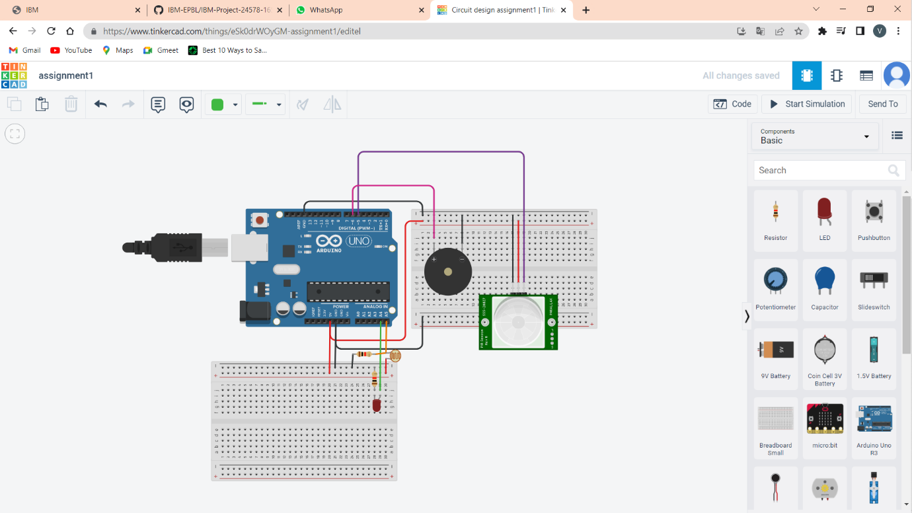

**OUTPUT SIMULATION:**

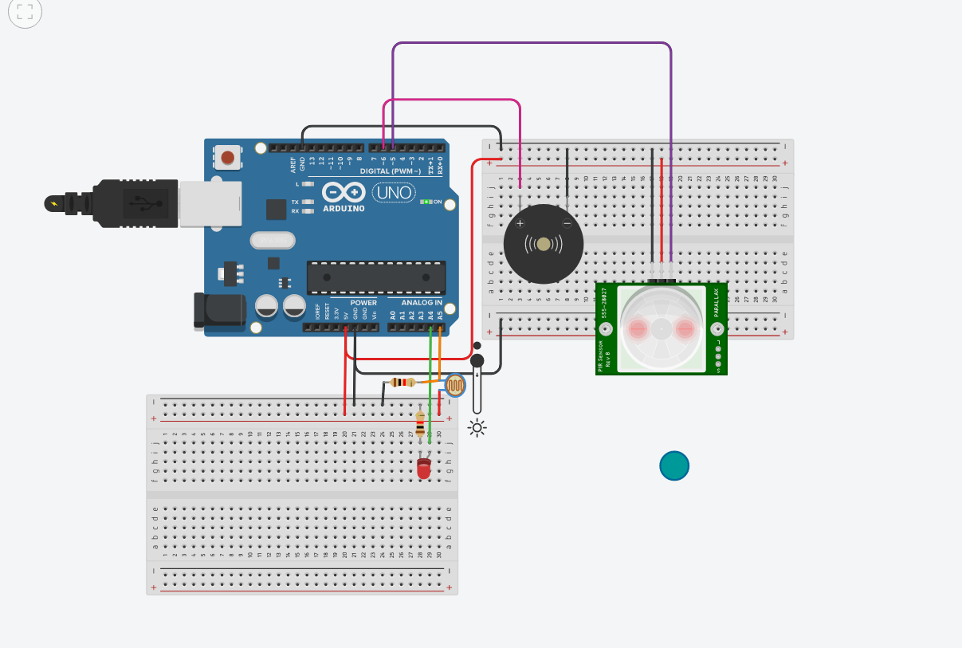

**CODE:**

int motionSensorPin = 5;

int motionAlertPin = 6;

int temperatutePin = 9;

int photoResistorSense = A5;

int photoResponseLight = A4;

void setup()

{

pinMode(motionSensorPin , INPUT);

pinMode(motionAlertPin , OUTPUT);

pinMode(temperatutePin , INPUT);

pinMode(photoResistorSense , INPUT);

pinMode(photoResponseLight , OUTPUT);

Serial.begin(9600);

}

void loop()

{

if(analogRead(photoResistorSense)<500){

digitalWrite(photoResponseLight , HIGH);

}

else{

digitalWrite(photoResponseLight , LOW);

}

Serial.println(analogRead(photoResistorSense));

if(digitalRead(motionSensorPin)){

digitalWrite(motionAlertPin , HIGH);

delay(1000);

digitalWrite(motionAlertPin, LOW);

}

delay(1000);

}